Usability Report

Table of Contents

1. Introduction 1
1.1. Usability 1
1.2. Importance of usability in the field of travelling. 2
2. Literature Review 3
Literature Review 1: 3
Literature Review 2: Usability Issues in Mobile Applications 4
3. Analysis 7
Schneiderman’s 8 Golden Rules: 7
Nielsen’s 10 Usability Heuristics: 13
4. Conclusion 15
5. References 16
6. Appendix 17

Table of Figures
Figure 1: Usability 1
Figure 2: Top 5 Usability Issues in Travel Mobile Apps 6
Figure 3: Strive for consistency 7
Figure 4: Enable frequent users to use shortcuts 8
Figure 5: Offer informative Feedback 8
Figure 6: Design dialog to yield closure(i) 9
Figure 7: Design dialog to yield closure(ii) 9
Figure 8: Offer simple error handling 10
Figure 9: Permit easy reversal of actions 10
Figure 10: Support internal locus of control 11
Figure 11: Reduce short-term memory load 12
Figure 12: Home page 17
Figure 13: Explore 18
Figure 14: user information / settings 19
Figure 15: Wish list 19
Figure 16: Hotels 20
Figure 17: News 20
Figure 18: Resturants 21
Figure 19: Transportation cost 21

Introduction

Usability
Usability or user-centered design refers to the practice of designing products with the ordinary person in mind. Learnability, Efficiency, Memorability, Errors, and Satisfaction are the five quality characteristics that are primarily used to describe usability. Learnability analyzes how easy it may be for consumers to utilize the system for the first time as well as what tries are necessary for users to become proficient at that task. Efficiency refers to the capacity to accomplish an assignment with the least amount of effort and time wasted. The ability of being memorable or deserving of recall is referred to as memorability. Errors relates to any faults a user makes while employing the products and how quickly they are capable of fixing such mistakes. Ultimately, satisfaction is the joy obtained while utilizing the product. Ultimately, usability is essential to a product or system's sustainability since it may seriously affect user adoption, engagement, and ultimately the success of the company or organization that developed and implemented it.

Figure 1: Usability

Source: https://www.webwisewording.com/wp-content/uploads/usability-venn-diagram3.jpg

Importance of usability in the field of travelling.
Usability is crucial in the travel industry since customers frequently have certain requirements that must be satisfied in order to have a pleasurable experience. These are some explanations on why usability is crucial in the travel industry:
- Efficiency: Whether it's discovering a new place or addressing a business meeting, travelers usually have a certain amount of time to complete their objectives. Usability can make it possible for visitors to quickly and simply access the information they demand, make reservations and bookings, and find their way around a new destination.
- Convenience: Traveling, particularly for individuals who aren't familiar with a new destination, may be stressful and confusing. By providing straightforward and easily understood details as well as making it simple to schedule accommodation, transportation, and other travel-related services, usability may help minimize stress.
- Loyalty: By guaranteeing that travelers have a good and hassle-free experience, usability may contribute in growing customer loyalty. Repeating business, favorable evaluations, and recommendations, all of which are essential to the achievement of travel agencies, might result from all this.
- Personalization: By rendering their services more user-friendly, travelers may availability of effective to the unique requirements and tastes of each traveler. For instance, by making customized suggestions for tours and destinations depending on the preferences and interests of the visitor.
Ultimately, usability is essential in the travel industry since it may influence a traveler's overall experience, from scheduling and organizing to actually visiting a new destination. (Foundation, 2023)

Literature Review

Literature Review 1:
This research utilized interaction design theories to the design of a platform for a travel application, using the idea of user experience aspects as a guide. These days, the research on the development of travel mobile applications employs a variety of research methods and survey subjects.
The application of design techniques involves a variety of components, including development platforms, conceptualizations, marketing plans, theoretical underpinnings, and many more. There are many research on product design based on the notion of user experience aspects, however there aren't many studies on the design of platforms for tourism applications. By the integration of user experience element models and commercial design development points, Wang Shuaiyu studies design methodologies and processes targeted at meeting the needs of tourists' equipment consumers, using the suitcase of typical personalized travel equipment as an example. Chen Huishu gathers and arranges the factors affecting the user experience of a travel APP before creating a conceptual model of the user experience. This model gives tourism product designers a theoretical framework and guidance for enhancing the user experience. (Yirun, et al., 2019)
In additional, for such consumer experience components, academics have suggested several feature models for various disciplines. Garrett made the first suggestion for the notion of user experience components. He developed five layers for the product creation and creation process: strategic, range, structure, framework, and presentation. The "Presence" influence factor was developed by Jane Lessiter et al. to quantify the user's immediate subjective sensation when using a system or medium. The three components of components that impact "Presence" are media form, media content, and user characteristic. Based on the perspective of the user, Hassenzahl developed an important defining model for the customer experience. Mahlke suggested that the user's emotional and mental emotions to the experience object should make up the majority of the user experience's core content and that a research methodology for consumer experience should be developed. Technical elements and non-technical features are about how Mahlke divides the psychological dimension of the UX in plane of existence.
According to the previously stated review of the literature, at this time, our UI / UX research on the tourism application platform focuses primarily on the macroscopic level research on the interaction design factors and models of travel implementation products, and there is a lack of the microscopic research on the methodology and process of particular tourism products. We may look at the design process through the lens of certain circumstances. The user experience variables in the research theory have several definitions and models for numerous research objects. The three-way platform at the beautiful setting under study for this essay is an example of an additional item. Garrett's user experience element theory, which is typically relevant to both information products and physical items, has a very distinct design element model. (Yirun, et al., 2019)

Literature Review 2: Usability Issues in Mobile Applications
This study will concentrate on the topic of usability problems in the creation of mobile applications, particularly for the travel, health, and institutions. In several databases, including Research Papers, IEEE Explorer, Science Direct, Emerald Insight, and Online Databases, we searched scholarly articles and papers. The academic magazines and articles examined for this study are those that were relatively recently published between 2011 and 2016.
In order to have thoughtful on the current issues some explanation of usability, interaction design, and user experience are as follows:
- Usability
This paper will approach the phrase "usability" using a concept that many scholars use as a point of reference. Usability is defined by International Standard ISO 9241-11 as the product's capacity to be understood, remembered, operated, and simple to use by users and may be utilized by certain users to achieve particular goals with performance, efficiency, and satisfaction. According to the product's usability must incorporate these three aspects:
- Efficiency: completing a task takes little time or effort.
- Less challenging to learn: By seeing the item, procedures may be performed and learnt.
- User satisfaction: satisfies user goals and expectations.

- Designing Interactions
Interface design and interaction design are interrelated because they work together to enable that users and interfaces interact, and since both are essential to the process of implementing procedures. The user's capacity for locating digital information is an important element when establishing an application's GUI. It is crucial to establish a contact between the user and the program because it is in a digital world. This procedure enables users to perform duties and raises engagement rates with the program. Given that HCI examines how people interact with various goods and technologies, interaction design is one of its research fields.
- User Experience (UX)
Numerous studies have recently emphasized on user experience design. Interaction design, technology architecture, graphic design, usability, and human computer interactive were the core elements of UX design. The purpose of UX design is to boost customer happiness and loyalty by strengthening a product's usability, portability, and enjoyment. According to UX design, people only take 5.0 seconds to establish an opinion of a website or service. This indicates that UX design focuses on having an in-depth knowledge of users, what they want, what they need, and how they feel. The user may then decide if they like it or not and if they want to stay or go. Accordingly, it's crucial to have a beautiful concept that has a big impact on the users.

Usability issues in travel app:
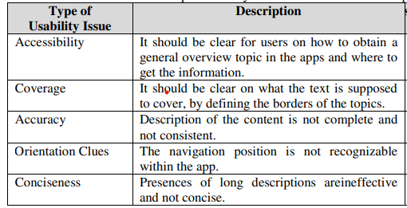

Figure 2: Top 5 Usability Issues in Travel Mobile Apps

Lastly, In order for other professionals in the field to take these challenges into consideration when establishing mobile applications for the education, health, and travel sectors, this study set out to illustrate a number of mobile application usability issues. In contrary, this study will help process development the usability challenges that they should consideration when they test and gauge the usability level of mobile applications. We advise other scientists to investigate usability issues in different industries in their future work. From there, usability flaws will be found from many different viewpoints. (Nur Amie Ismail, 2016)
- The two products based on my field of study are:
- Trivago
- Makemytrip

Analysis
The analysis is based on two travel applications trivago and makemytrip whereas the analysis is based on Schneiderman’s 8 Golden Rules and Nielsen’s 10 Usability Heuristics.

Schneiderman’s 8 Golden Rules:
- Strive for consistency
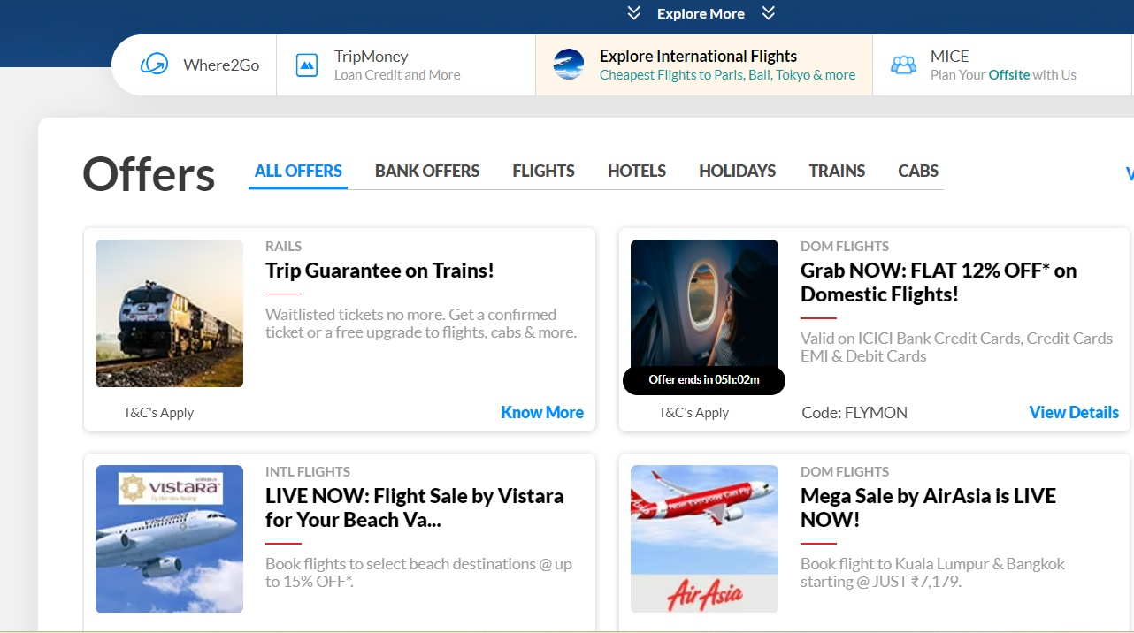
Figure 3: Strive for consistency

Similar information are seen horizontally and vertically.

- Enable frequent users to use shortcuts
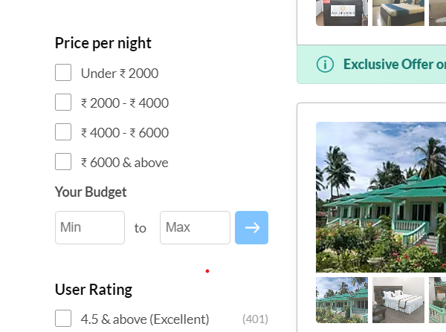
Figure 4: Enable frequent users to use shortcuts
User can directly give the price range.

- Offer informative Feedback
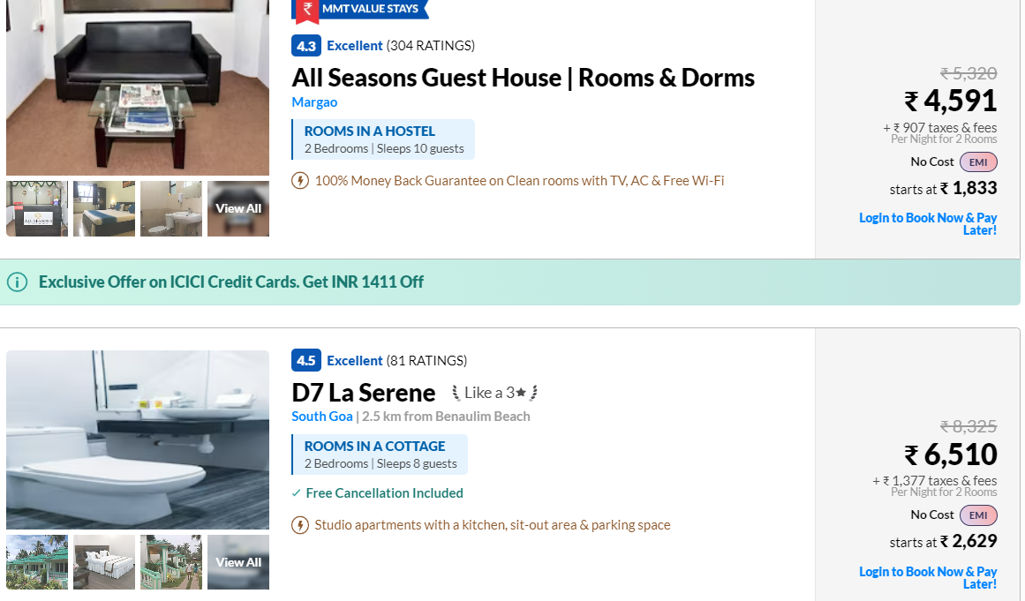
Figure 5: Offer informative Feedback
User can easily read the various information without even chatting or interacting to a person.

- Design dialog to yield closure
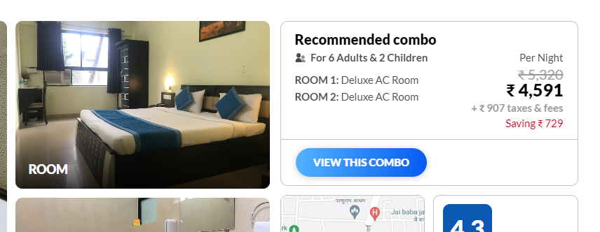
Figure 6: Design dialog to yield closure(i)
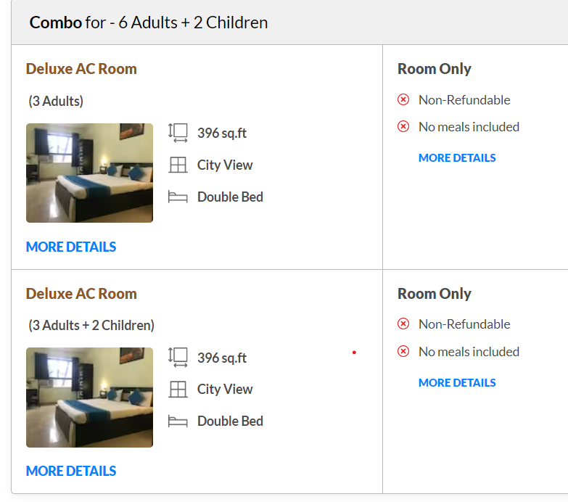
Figure 7: Design dialog to yield closure(ii)
By clicking the button we will be redirected to the following information.

- Offer simple error handling
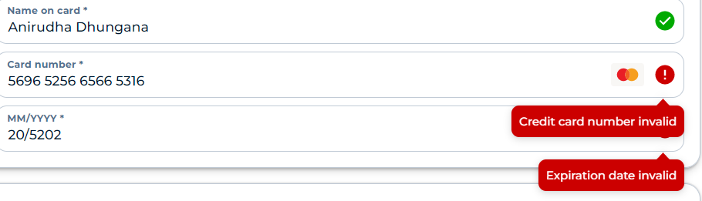
Figure 8: Offer simple error handling
Simple error should be shown with the cause.

- Permit easy reversal of actions
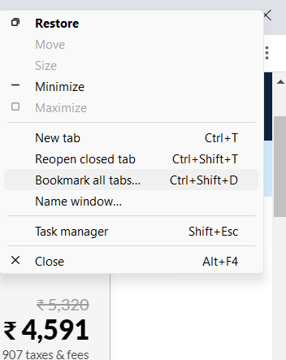
Figure 9: Permit easy reversal of actions

User can easily undo their changes without any complications.
- Support internal locus of control

Figure 10: Support internal locus of control
Various control can be shown from the single page.

- Reduce short-term memory load
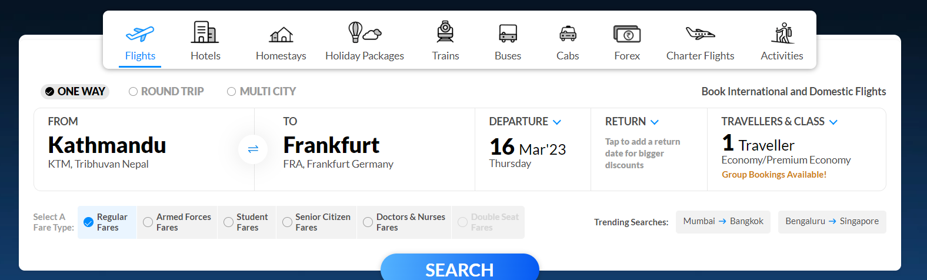
Figure 11: Reduce short-term memory load
Same work can be done from various ways.

Images and information are taken from:
(makemytrip, 2023)
(trivago, 2023)

Nielsen’s 10 Usability Heuristics:
- Visibility of system status
- It Keep the user advised on what's happening.

- Match between system and the real world
- Implement ordinary language rather than scientific language.

- User control and freedom
- The client has authority over the system, for illustration, undo/redo, etc.

- Consistency and standards
- Users shouldn't be required to guess when certain expressions, events, or actions are identical, correspond to platform and quality requirements.

- Error prevention
- Although clear error warnings are vital, the strongest solutions are those that minimize issues completely.

- Recognition rather than recall
- Information shouldn't have to be maintained as the user leaves from one portion of the screen to another. Field labels and menu items, for illustration, should be immediately evident or simple to find as you navigate the design.

- Flexibility and efficiency of use
- In the interests of accommodating both novice and seasoned users, bypasses may speed up engagement for the experienced operator while maintaining concealed from beginner users. Let users to modify predictable actions.

- Aesthetic and minimalist design
- Evidence that is unwanted or uncommonly used shouldn't really be present in interactions. Each additional informational item that is supplementary to a dashboard conflicts with the crucial fragments and diminishes their overall accessibility.

- Help users recognize, diagnose, and recover from errors
- Error messages ought to be conveyed in simple English, accurately describe the problem, and clearly provide a remedy.

- Help and documentation
- The ideal condition is when the structure is transparent. To guarantee that customers are capable of carrying out their responsibilities, it could be required to offer documentation. (Norman, 2023)

Conclusion
There are numerous elements that need to be taken into account while creating the UI/UX, design is not just about pleasing to the eyes. As stated in the journals, several studies have been conducted in the field of designing, and in order for an interface to be stable over the long term, we need abide by the different golden principles while creating or building it.
A significant amount of research has indeed been published in both journals that emphasizes the value of user-centered design and the consequences of interface complexity on user engagement, satisfaction, and task performance. To ensure digital platforms are user-friendly and provide a good user experience, it is crucial to prioritize usability and user-centered design. This involves understanding the needs and preferences of the target audience and creating intuitive and easy-to-use interfaces. It is advisable for businesses and organizations to conduct usability testing and research to enhance the design and functionality of their digital platforms.

References
Foundation, I. D., 2023. Usability. [Online]
Available at: https://www.interaction-design.org/literature/topics/usability
makemytrip, 2023. makemytrip. [Online]
Available at: https://www.makemytrip.com/
Norman, N., 2023. 10 Usability Heuristics for User Interface Design. [Online]
Available at: https://www.nngroup.com/articles/ten-usability-heuristics/
Nur Amie Ismail, F. A. N. A. K. R. I., 2016. Journal of Mobile Computing & Application. A Review on Usability Issues in Mobile Applications, 3(3), pp. 47-52.
trivago, 2023. [Online]
Available at: https://www.trivago.com/
Yirun, Junyong & Zhang, 2019. Journal of Service Science and Management. Research on Interactive Design of Three-Way Interactive Platform in Scenic Spots—Based on the Theory of User Experience Elements, Volume 12.

Appendix
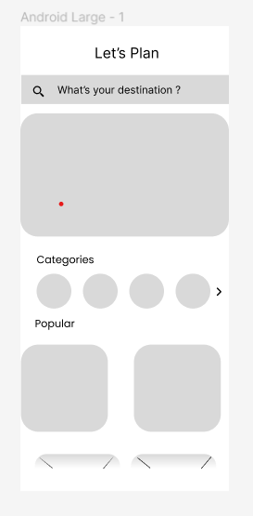
Figure 12: Home page

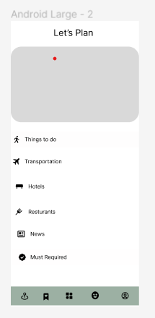

Figure 13: Explore

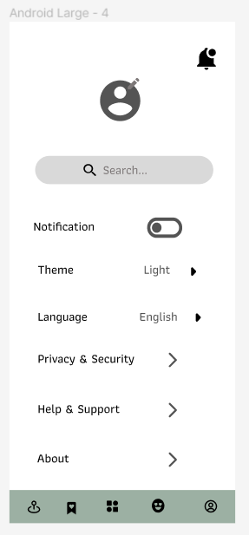
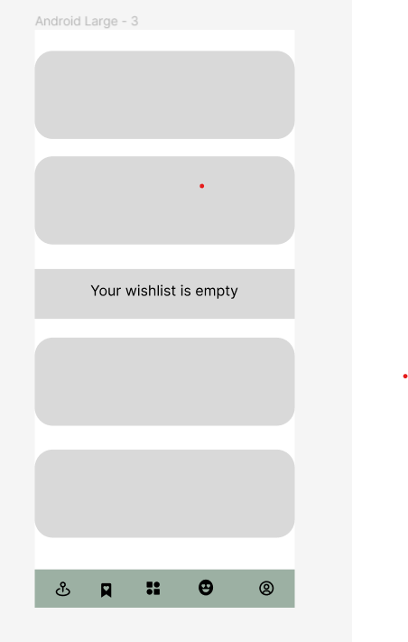
Figure 14: user information / settings
Figure 15: Wish list



Figure 16: Hotels
Figure 17: News


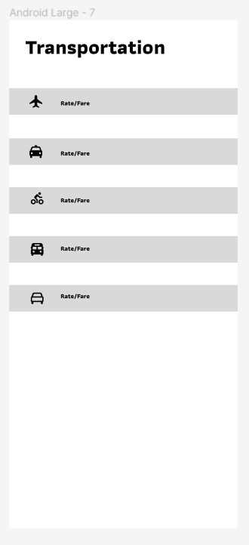
Figure 18: Resturants
Figure 19: Transportation cost

Link to wireframe:
https://www.figma.com/file/YyMrrINREeQKZHsjbJvc7H/Untitled?node-id=0%3A1&t=ylKEQ3n6dyBkAXVE-1

